DSA Practice

Data Structures and Algorithms (DSA) form the foundation of problem-solving in computer science. Mastering DSA helps you write efficient and optimized code.
What is an Algorithm?
In computer programming terms, an algorithm is a set of well-defined instructions to solve a particular problem. It takes a set of input(s) and produces the desired output. For example,
An algorithm to add two numbers:
- Take two number inputs
- Add numbers using the + operator
- Display the result

Data Structure and Types
What are Data Structures?
Data structure is a storage that is used to store and organize data. It is a way of arranging data on a computer so that it can be accessed and updated efficiently.
Depending on your requirement and project, it is important to choose the right data structure for your project. For example, if you want to store data sequentially in the memory, then you can go for the Array data structure.
Note: Data structure and data types are slightly different. Data structure is the collection of data types arranged in a specific order.
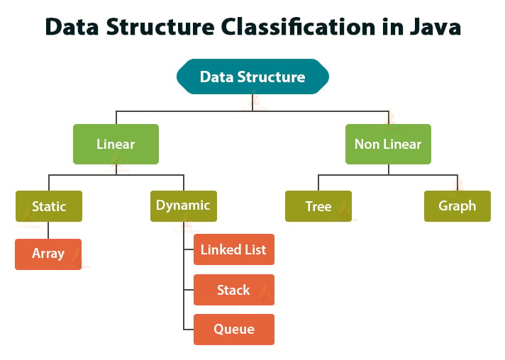
Types of Data Structure:
Basically, data structures are divided into two categories:
- Linear data structure
- Non-linear data structure

Linear data structures:
In linear data structures, the elements are arranged in sequence one after the other. Since elements are arranged order, they are easy to implement.
However, when the complexity of the program increases, the linear data structures might not be the best choice because of operational complexities.
Array Data Structure: Every value stored in one variable for we need to create multiple variables but it not good approach because creating multiple variables for multiple values it may occupy huge memory. If we have same data type values in that case, we use ARRAYS.
For Example: If we have number String values, we use String [] array names []my-array. For Example: If we have number Integer values, we use Integer [] array values []my-array.
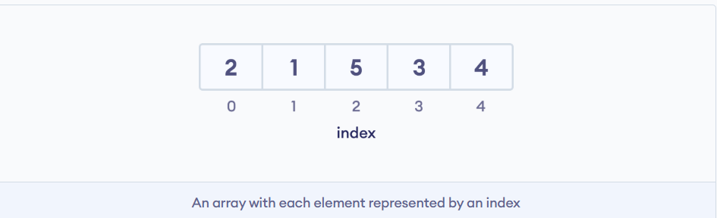
Arrays are index-based values means if we want to get values from array. We must use their index number. Through index values we can call the values.

Stack Data Structure:
In stack data structure, elements are stored in the LIFO principle. That is, the last element stored in a stack will be removed first.
It works just like a pile of plates where the last plate kept on the pile will be removed first.

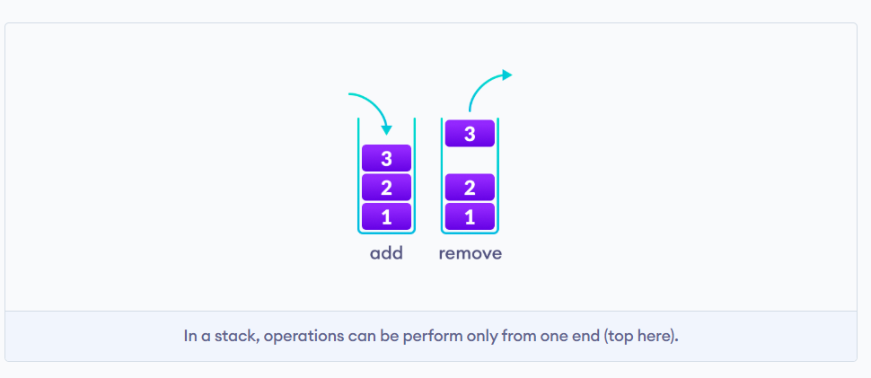

Queue Data Structure:
Unlike stack, the queue data structure works in the FIFO principle where first element stored in the queue will be removed first.
It works just like a queue of people in the ticket counter where first person on the queue will get the ticket first.
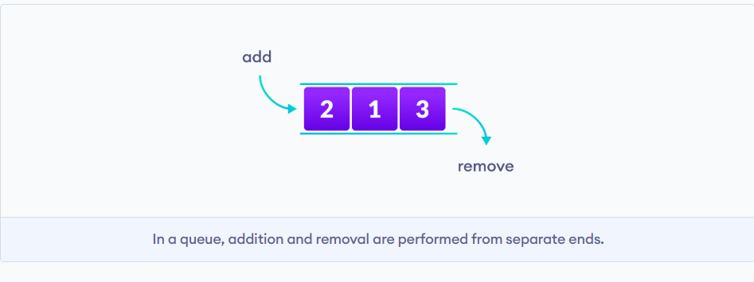
Linked List Data Structure:
In linked list data structure, data elements are connected through a series of nodes. And each node contains the data items and address to the next node.
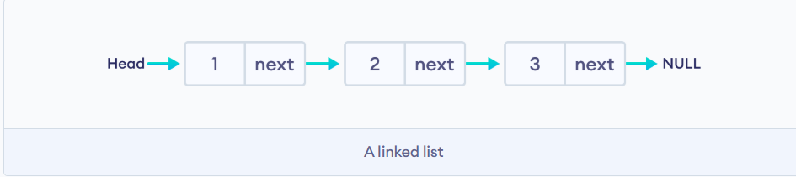
Non-linear data structures:

